Lab 1 Enhanced Binary Adder Lab Report

CS211 Summer 2017

June 12, 2017

Xu Mingzhi

**Table of Content**

1. Objective 3

2. Half-Adder 4

2.1 Functionality and Specifications 4

2.2 Simulation 5

2.3 Demonstration 5

3. One Bit Full Adder using Gates 8

3.1 Functionality and Specifications 8

3.2 Simulation 9

3.3 Demonstration 10

4. One Bit Full Adder using Half-Adder as a component 12

4.1 Functionality and Specifications 12

4.2 Simulation 14

4.3 Demonstration 15

5. 4-Bit Full Adder using 1-Bit Full Adder as a component 17

5.1 Functionality and Specification 17

5.2 Simulation 19

5.3 Demonstration 20

6. 4-Bit Full Adder/Subtractor 23

6.1 Functionality and Specification 23

6.2 Simulation 25

6.3 Demonstration 27

7. Conclusion 32

# **Objective**

In this lab, we will be using what we have learned from the tutorial that explained the basic tools for designing circuits in Quartus Prime to build circuits for binary adders, run waveform simulation that correspond to the truth table that defines the circuit, and loading the circuits onto the DE1-SoC board to test if the result corresponds to the simulations and the truth table. The circuit that we will be designing includes:

1. Half-Adder
2. One Bit Full Adder using Gates
3. One Bit Full Adder using Half-Adder
4. 4-Bit Full Adder using 1-Bit Full Adder
5. 4-Bit Full Adder/Subtractor

# **2. Half-Adder**

## ***2.1 Functionality and Specifications***

The Half-Adder takes two inputs x, y and add them up in base 2 form and produces two outputs, the sum s and carry over c. Since it is a binary adder and binary are in base 2 form so only 0 and 1 are used in this addition. Below is the truth table of all possible input for x and y along with the Boolean function that defines the two outputs s and c.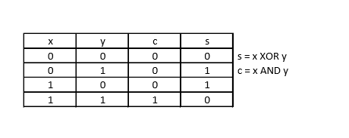

When the Boolean function is applied to the block diagram, a XOR gate and an AND gate is used to design the circuit for Half-Adder. The XOR gate will take x and y as inputs and outputs s. The AND gate will also take x and y as inputs and outputs c.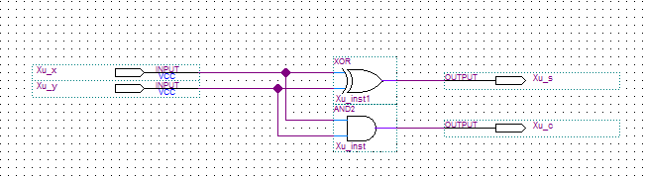Figure 1: Block diagram of Half-Adder

## ***2.2 Simulation***

In the simulation, values of 0 and 1 will be the input for x and y at varying intervals. Input x will have value of 0 and 1 at each 320ns interval. Input y will have values of 0 ad 1 at each 160ns interval.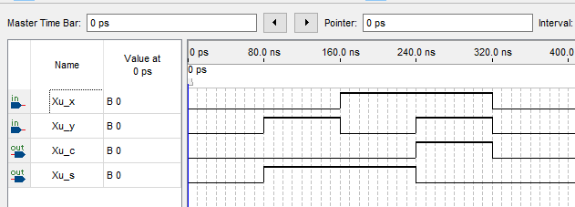

Figure 2: Vector waveform simulation corresponding to Half-Adder

We can observe that when either input x or y has the value of 1 then the output of c will be 0 and the sum s will be 1 and when both input x and y has the value of 1 then the output of c will be 1 and the sum s will be 0. These results correspond to the inputs and outputs shown on the truth table.

## ***2.3 Demonstration***

The inputs and outputs are assigned to pins on the DE1-SoC Board.

Xu_x is assigned to SW[0] which is PIN_AB12

Xu_y is assigned to SW[1] which is PIN_AC12

Xu_s is assigned to LEDR[0] which is PIN_V16

Xu_c is assigned to LEDR[1] which is PIN_W16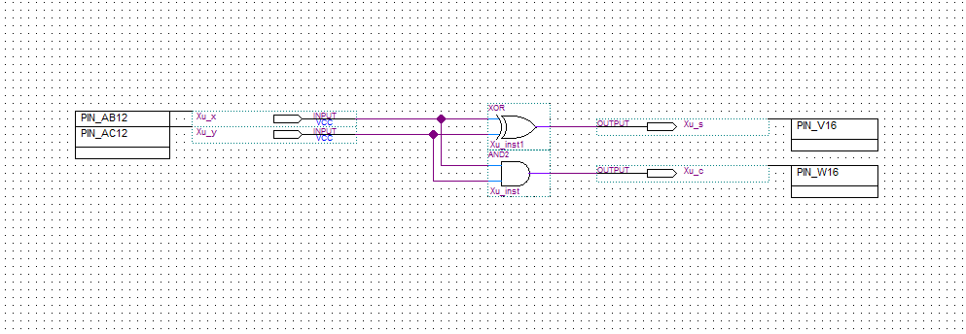Figure 3: PIN assignments of the Half-Adder circuit to DE1-SoC Board.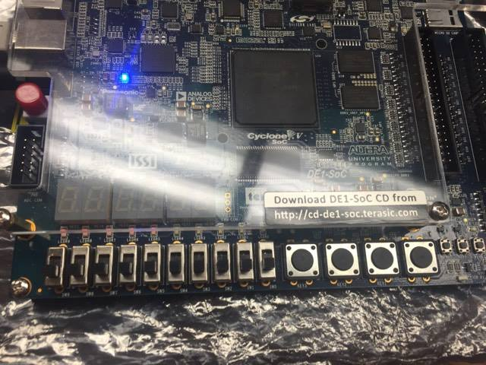Figure 4: PIN assignment on the DE1-SoC Board

Xu_x

Xu_y

Xu_s

Xu_c

Figure 5: Digital circuit when x is 0 (off) and y is 1 (on), output of s is 1 (on) c is 0 (off) 

Figure 6: Digital circuit when x is 1 (on) and y is 1 (on), output of s is 0 (off) c is 1 (on)

# **3. One Bit Full Adder using Gates**

## ***3.1 Functionality and Specifications***

A One Bit Full Adder will have three inputs carry-in c, x and y and produces two outputs carry-out c1 and sum s. The idea of a Full Adder is similar to a Half-Adder but includes an additional input of a carry-in c. Below is a truth table that displays all of the possible inputs for x, y and carry-in c along with the Boolean function that defines the output sum s and carry-out c1.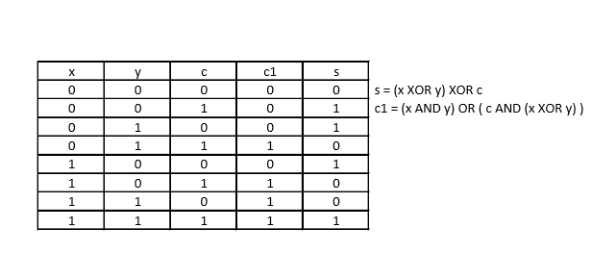

When the Boolean function is applied to the block diagram, two XOR gate, two AND gate, and an OR gate is used to design the circuit for One Bit Full Adder using Gates. A XOR gate takes the output of another XOR that takes x and y as input and the carry-in c to produce the sum s. An OR gate takes output of x AND y and c AND (x XOR y) as inputs produce the carry-out c1.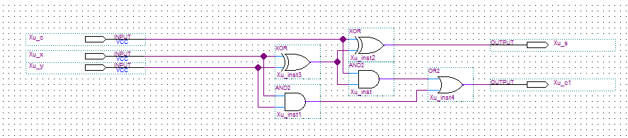

Figure 7: Block diagram of One Bit Full Adder using Gates

## ***3.2 Simulation***

In the simulation, values of 0 and 1 will be the input for x, y and carry-in c at varying intervals. Input x will have value 0 and 1 at each 640ns interval. Input y will have value of 0 and 1 at each 320ns interval. Input carry-in c will have value 0 and 1 at each 160ns interval. 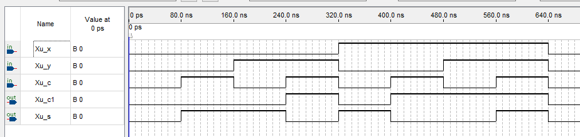

Figure 8: Vector waveform simulation corresponding to One Bit Full Adder using Gates

We can observe that when both x and y inputs are 0 and the carry-in c is 1 the output sum s will be 1 and carry-out c1 will be 0. When either x or y is 1 and carry-in c is 0 the output will be sum s is 1 and carry-out c1 will be 0. When either x or y is 1 and carry-in c is 1 the output sum s will be 0 and carry-out c1 will be 1. When all the inputs are 1 the output for both sum s and carry-out c1 will also be 1. The results on the simulation correspond to the truth table that defines One Bit Full Adder using Gates

## ***3.3 Demonstration***

The inputs and outputs are assigned to pins on the DE1-SoC Board.

Xu_x is assigned to SW[0] which is PIN_AB12

Xu_y is assigned to SW[1] which is PIN_AC12

Xu_c is assigned to SW[2] which is PIN_AF9

Xu_s is assigned to LEDR[0] which is PIN_V16

Xu_c1 is assigned to LEDR[1] which is PIN_W16

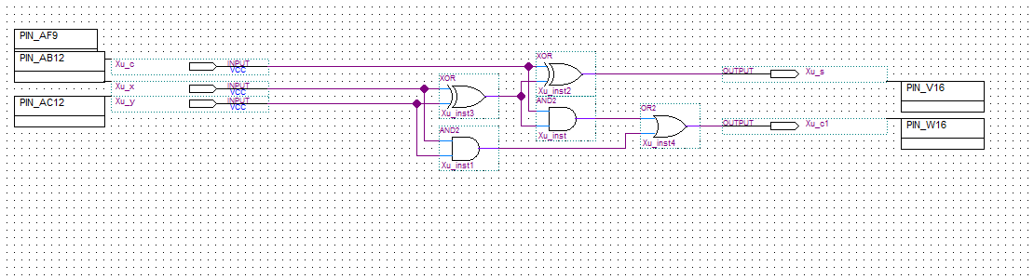Figure 9: PIN assignments of Full Adder using Gates circuit to DE1-SoC Board



Xu_x

Xu_y

Xu_c

Xu_s

Xu_c1

Figure 10: PIN assignment on the DE1-SoC Board



Figure 11: Inputs x is 0 (off) y is 1 (on) c is 0 (off) outputs c1 is 0 (off) s is 1 (on)



Figure 12: Input x is 1 (on) y is 1 (on) c is 1 (on) Outputs c1 is 1 (on) s is 1 (on)

# **4. One Bit Full Adder using Half-Adder as a component**

## ***4.1 Functionality and Specifications***

A One Bit Full Adder using Half-Adder as a component is the same as One Bit Full Adder using Gates. Therefore, it will have the same truth table and Boolean function such that it will have three inputs carry-in c, x and y and produces two outputs carry-out c1 and sum s. Below is a truth table that displays all the possible inputs for x, y and carry-in c along with the Boolean function that defines the output sum s and carry-out c1.



When the Boolean function is applied to the block diagram, two XOR gate, two AND gate, and an OR gate is used to design the circuit for One Bit Full Adder using Gates. A XOR gate takes the output of another XOR that takes x and y as input and the carry-in c to produce the sum s. An OR gate takes output of x AND y and c AND (x XOR y) as inputs produce the carry-out c1. Since it is a Full Adder using Half-Adder as a component, and Half-Adder circuit contains one XOR gate and one AND gate, so therefore we can convert the two XOR gate and two AND gate that is used in the Full Adder using Gates into two blocks of Half-Adder as component.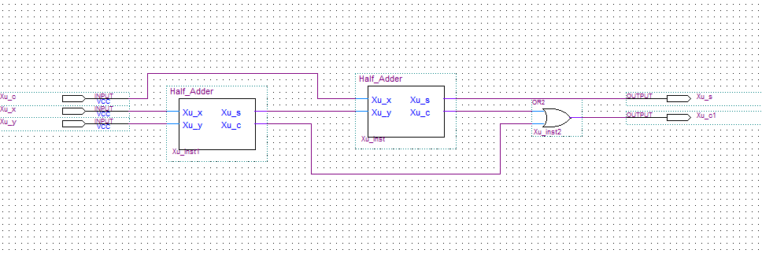

Figure 13: Block diagram of Full Adder using Half-Adder as a component

## ***4.2 Simulation***

In the simulation, values of 0 and 1 will be the input for x, y and carry-in c at varying intervals. Input x will have value 0 and 1 at each 640ns interval. Input y will have value of 0 and 1 at each 320ns interval. Input carry-in c will have value 0 and 1 at each 160ns interval. It is the same as the Full Adder using Gates since it shares the same truth table and Boolean function.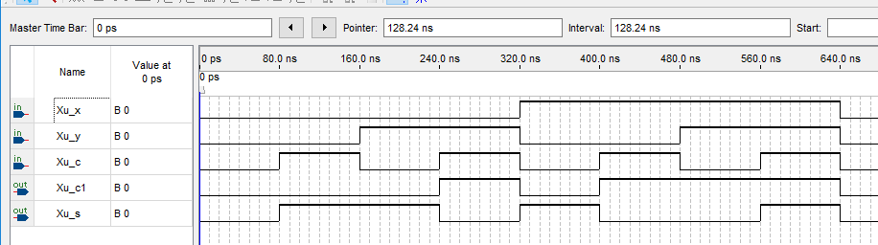

Figure 14: Vector waveform simulation corresponding to One Bit Full Adder using Half-Adders

We can observe that when both x and y inputs are 0 and the carry-in c is 1 the output sum s will be 1 and carry-out c1 will be 0. When either x or y is 1 and carry-in c is 0 the output will be sum s is 1 and carry-out c1 will be 0. When either x or y is 1 and carry-in c is 1 the output sum s will be 0 and carry-out c1 will be 1. When all the inputs are 1 the output for both sum s and carry-out c1 will also be 1. The results on the simulation correspond to the truth table that defines One Bit Full Adder using Half-Adders.

## ***4.3 Demonstration***

The inputs and outputs are assigned to pins on the DE1-SoC Board.

Xu_x is assigned to SW[0] which is PIN_AB12

Xu_y is assigned to SW[1] which is PIN_AC12

Xu_c is assigned to SW[2] which is PIN_AF9

Xu_s is assigned to LEDR[0] which is PIN_V16

Xu_c1 is assigned to LEDR[1] which is PIN_W16

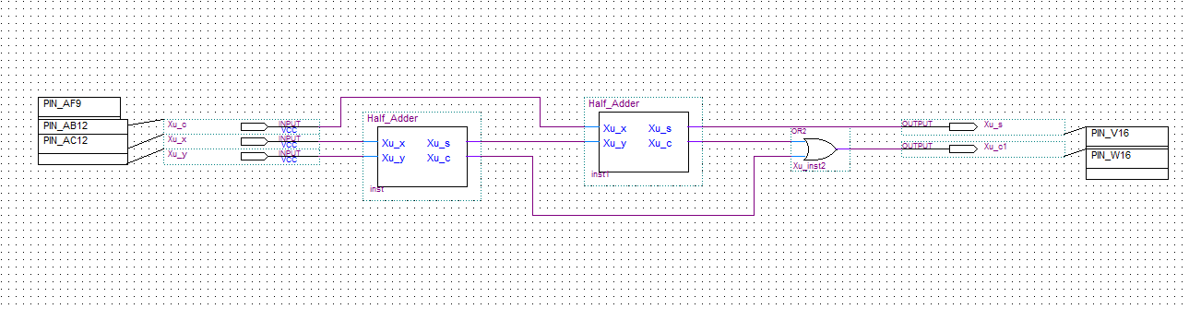

Figure 15: PIN assignments of Full Adder using Gates circuit to DE1-SoC Board

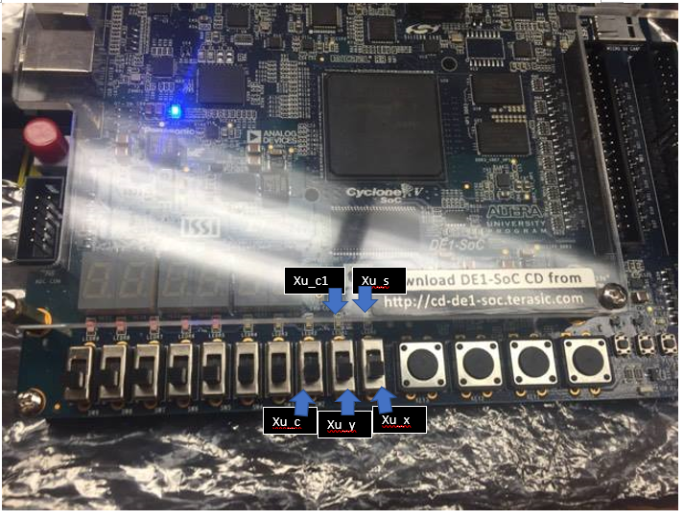

Figure 16: PIN assignment on the DE1-SoC Board



Figure 17: Input x is 0 (off) y is 0 (off) c is 1 (on) Outputs c1 is 0 (off) s is 1 (on)



Figure 18: Input x is 1 (on) y is 1 (on) c is 1 (on) Outputs c1 is 1 (on) s is 1 (on)

# **5. 4-Bit Full Adder using 1-Bit Full Adder as a component**

## ***5.1 Functionality and Specification***

A 4-Bit Full Adder using 1-Bit Full Adder as a component would require using 4 Full Adder meaning there will be 9 inputs and producing 5 outputs. Since there are 9 inputs so is 512 possible inputs which is going to be overly long if it were to implement onto a truth table. So here below is a shorten truth table of a 4-Bit Full Adder and Boolean functions.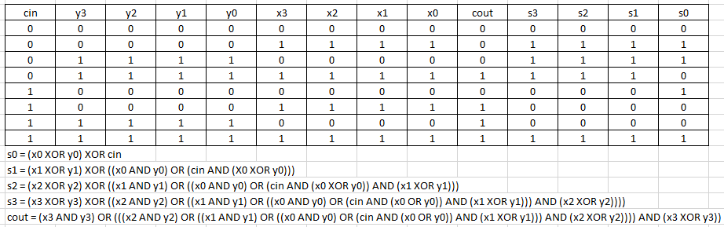

When the Boolean function is applied to the block diagram, there will be 8 XOR gates, 8 AND gates, and 4 OR gates. Which makes up 4 One-Bit Full Adder and created into a Full Adder component.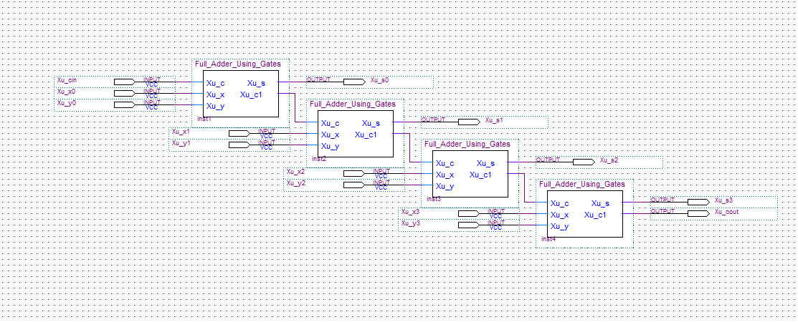

Figure 18: Block diagram of 4-Bit Full Adder using Full Adder as a component

## ***5.2 Simulation***

In the simulation, values of 0 and 1 will be the input for cin, x0, x1, x2, x3, y0, y1, y2, y3, cout, s3, s2, s1, and s0 at varying intervals. Input cin will value of 0 and 1 at each 800ns interval. Input x0, x1, x2, and x3 will have value of 0 and 1 at each 200ns interval. Input y0, y1, y2, and y3 will have values of 0 and 1 at each 400ns interval.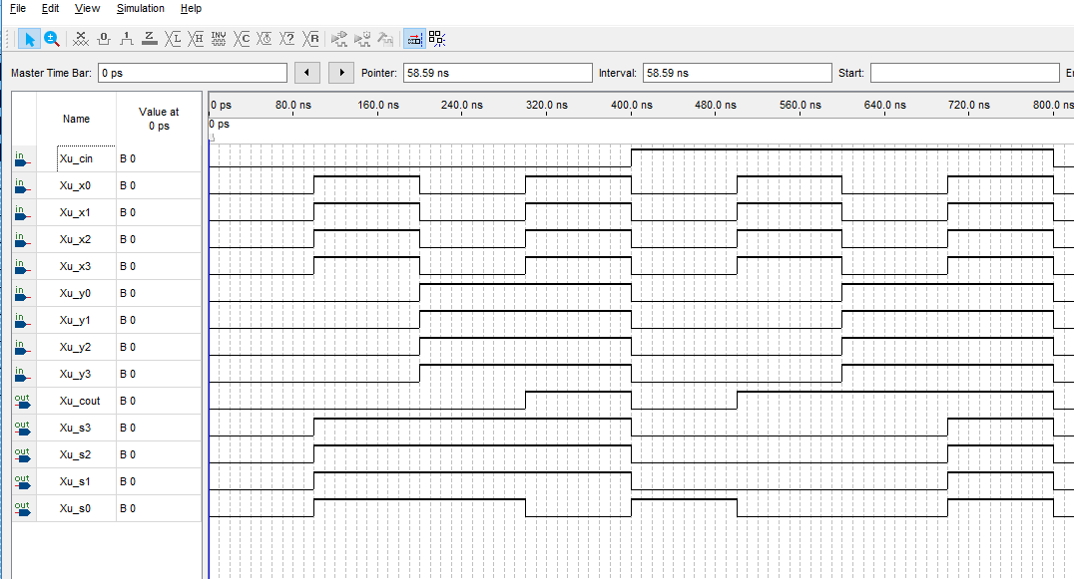 Figure 19: Vector waveform simulation corresponding to 4-Bit Full Adder using Full Adder

We can observe that when input cin is 0 and either all x inputs or y inputs are 1 the output of all s will be 1 and cout will be 0. When cin is 0 and all x and y inputs are 1 the output will be s0 is 0 and all other s output and cout will be 1. When cin is 1 and either x inputs or y inputs are 1 the output will be s0 and cout will be 1 and all other s output will be 0. When all inputs are 1 then all outputs are 1. The results of the simulation corresponds to the truth table that defines the 4-Bit Full Adder using 1-Bit Full Adder as a component.

## ***5.3 Demonstration***

The inputs and outputs are assigned to pins on the DE1-SoC Board.

Xu_x0 is assigned to SW[0] which is PIN_AB12

Xu_x1 is assigned to SW[1] which is PIN_AC12

Xu_x2 is assigned to SW[2] which is PIN_AF9

Xu_x3 is assigned to SW[3] which is PIN_AF10

Xu_y0 is assigned to SW[4] which is PIN_AD11

Xu_y1 is assigned to SW[5] which is PIN_AD12

Xu_y2 is assigned to SW[6] which is PIN_AE11

Xu_y3 is assigned to SW[7] which is PIN_AC9

Xu_cin is assigned to SW[8] which is PIN_AD10

Xu_s0 is assigned to LEDR[0] which is PIN_V16

Xu_s1 is assigned to LEDR[1] which is PIN_W16

Xu_s2 is assigned to LEDR[2] which is PIN_V17

Xu_s3 is assigned to LEDR[3] which is PIN_V18

Xu_cout is assigned to LEDR[4] which is PIN_W17

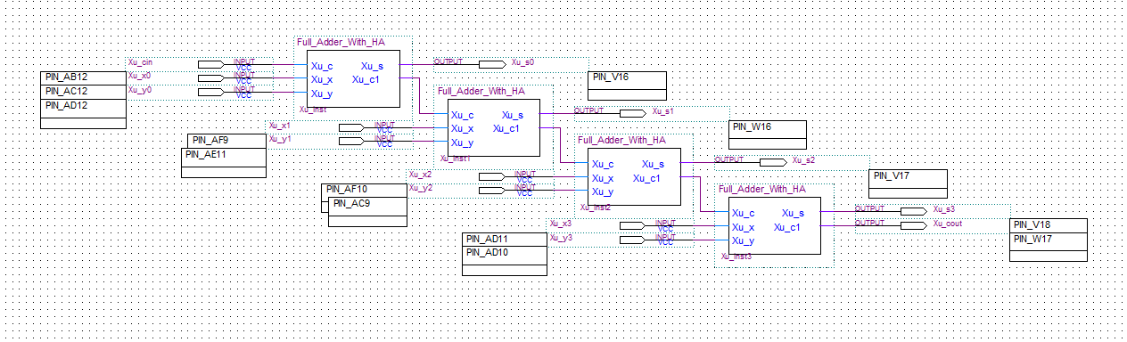

Figure 20: PIN assignments of 4-Bit Full Adder using Full Adders circuit to DE1-SoC Board

Xu_x0

Xu_cout

Xu_s3

Xu_s2

Xu_s1

Xu_s0

Xu_cin

Xu_y3

Xu_y2

Xu_y1

Xu_y0

Xu_x3

Xu_x2

Xu_x1

Figure 21: PIN assignment on the DE1-SoC Board



Figure 22: inputs x0, x1, x2, x3 is 1 (on) y0, y1, y2 ,y3, cin is 0 (off) outputs s0, s1, s2, s3 is 1 (on) and cout is 0 (off)



Figure 23: inputs x0, x1, x2, x3, y0, y1, y2, y3 is 1 (on) cin is 0 (off) outputs s0 is 0(off) s1, s2, s3 and cout is 1 (on)

# **6. 4-Bit Full Adder/Subtractor**

## ***6.1 Functionality and Specification***

The 4-Bit Full Adder/Subtractor is built on top of the 4-Bit full adder using full adder as components which means it is using the full adder as a base and expand it into an adder/subtractor whereas there will be a button M that determines if the adder is doing addition or subtraction. There will be an output Z that determines if the addition or subtraction will result 0 which mean the output for s0 s1 s2 s3 will be 0. There will also be an output V to determine if the addition or subtractor is overflow since the addition or subtractor will be signed which means the possible result for 4-bit adder/subtractor will be ranged from -8 to 7 and anything out of this range will be consider as overflow. Then there will be an output N which determines the sign for the final output of s0 s1 s2 s3 to determine if it is negative or positive, N will be determined by running a 2:1 multiplexer that takes V as a selector, s3 and cout as inputs. Therefore N will be determined by s3 and cout, when the selector V is off it will be s3 when V is on it will be cout. Below is a truth table that shows some of the cases that will be tested by the simulation.

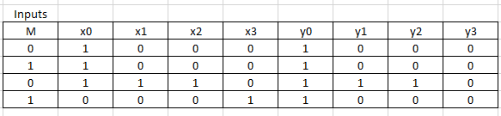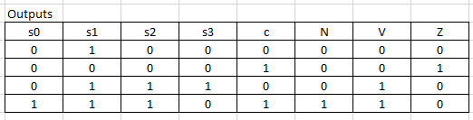

The Boolean functions for s0, s1, s2, s3, and c will be the same as the one in the 4-bit full adder.

The Boolean Functions for other outputs:

N = (NOT V AND s3) OR (V AND c)

V = c XOR (cout of s2)

Z = NOT(s0 OR s1 OR s2 OR s3 OR c)

When the Boolean function is applied to create a block diagram for the adder/subtractor, there will be four one-bit full adder as component, five XOR gate, one AND gate, one NOR gate that takes five inputs, and a 2:1 multiplexer. Each y inputs will go through a XOR gate that takes the y and M as inputs which determines if it is functioning as addition of subtraction. V will be the input of c XOR cout from the third full adder which determines if the addition or subtraction is being overflow or not. N will be the output of a 2:1 multiplexer that takes in V as the selector, c and s3 as inputs to determine if the sign for the result to be negative or positive which is determined by the c and s3. If the selector V is 0 then it will take s3 as output meaning 0 is positive and 1 is negative, if V is 1 then it’ll take c as output since it is an overflow result it’ll look at the carryout c to determine if it is positive or negative. Finally, Z checks if the result is 0 which means s0 s1 s2 s3 will be 0 and the result is not an overflow by V AND c.

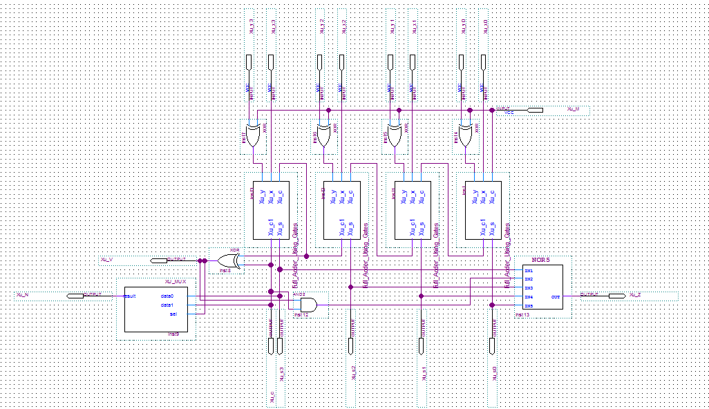Figure 24: Block diagram for adder/subtractor.

## ***6.2 Simulation***

In the simulation, input M will have values of 0 and 1 at each 400-ns interval. Since the simulation will be testing specify cases based on the truth table. Input x0 will have values of 1 and 0 at each 600-ns interval. Input x1 and x2 will have value of 1 from 400-ns to 600-ns. Input x3 will have value of 1 from 600-ns to 800-ns. Input y0 will have values of 1 and 0 at each 1600-ns interval. Input y1 and y2 will have value of 1 from 400-ns to 600-ns. Input y3 will have value of 1 from 600-ns to 800-ns.

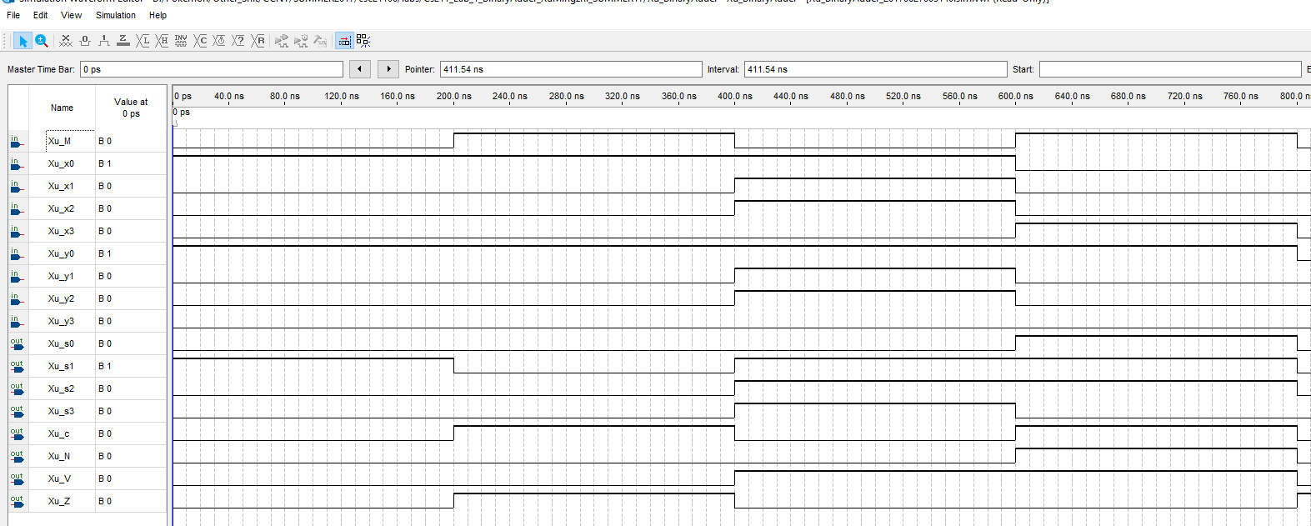Figure 25: Vector waveform simulation of adder/subtractor.

We can observe from the simulation that when input 0001 for x and 0001 for y while M is 0 it is doing addition of 1 and 1 which outputs 2 therefore only s1 will be 1 and all other outputs are 0. The same input when M is 1 it is doing subtraction of 1 and 1 and the output should be 0 for s0 s1 s2 s3 N, and V. Therefore Z will be 1, since M has input of 1 in order for this to function as a subtraction the c will be 1 but since V is not 1 it is not an overflow subtraction therefore c will be ignored and Z will be 1. When input for x0, x1, x2, y0, y1, y2 are 1, input x3 and y3 are 0 when M is 0, it is doing addition for 0111 and 0111 which is 7 + 7 and normally the result will be 14 but it is an overflow since the range for 4-bit adder signed will be -8 to 7 and therefore V will 1 and the output will be 1110 and since V is 1, N will take from c which is 0 that determines the result to be 1110 which is 14 else normally 1110 represents -2. The last one will test 1000 subtract 0001 or -8 – 1 which normally would be -9 and again it is an overflow since it only can be range from -8 to 7 and the output is 0111 which is 7 which is incorrect but V is 1 and since V is 1, N will take from c and c is also 1 so the whole result would be 1 1110 which is -9. These simulation results correspond to the truth table and Boolean function.

## ***6.3 Demonstration***

The inputs and outputs are assigned to pins on the DE1-SoC Board.

Xu_x0 is assigned to SW[0] which is PIN_AB12

Xu_x1 is assigned to SW[1] which is PIN_AC12

Xu_x2 is assigned to SW[2] which is PIN_AF9

Xu_x3 is assigned to SW[3] which is PIN_AF10

Xu_y0 is assigned to SW[4] which is PIN_AD11

Xu_y1 is assigned to SW[5] which is PIN_AD12

Xu_y2 is assigned to SW[6] which is PIN_AE11

Xu_y3 is assigned to SW[7] which is PIN_AC9

Xu_M is assigned to KEY[0] which is PIN_AA14

Xu_s0 is assigned to LEDR[0] which is PIN_V16

Xu_s1 is assigned to LEDR[1] which is PIN_W16

Xu_s2 is assigned to LEDR[2] which is PIN_V17

Xu_s3 is assigned to LEDR[3] which is PIN_V18

Xu_c is assigned to LEDR[4] which is PIN_W17

Xu_N is assigned to LEDR[5] which is PIN_W19

Xu_V is assigned to LEDR[6] which is PIN_Y19

Xu_Z is assigned to LEDR[7] which is PIN_W20

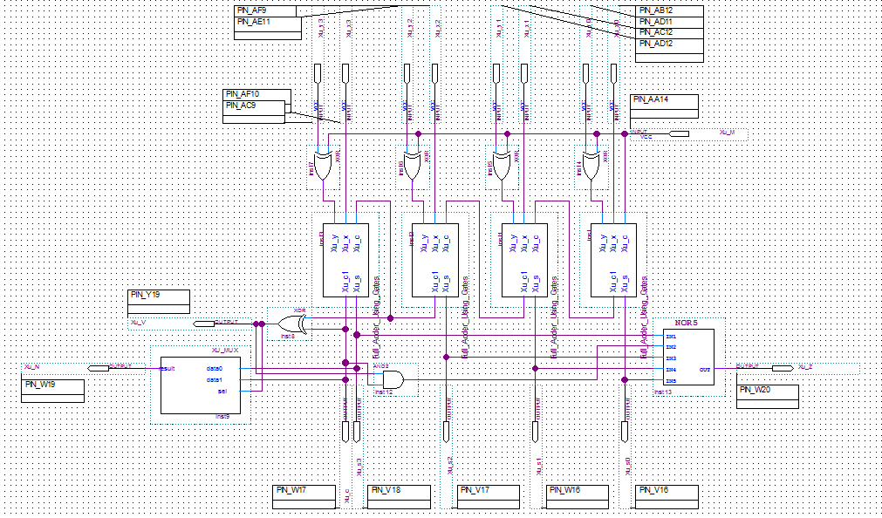Figure 26: PIN assignment of circuit onto the DE1-SoC Board.

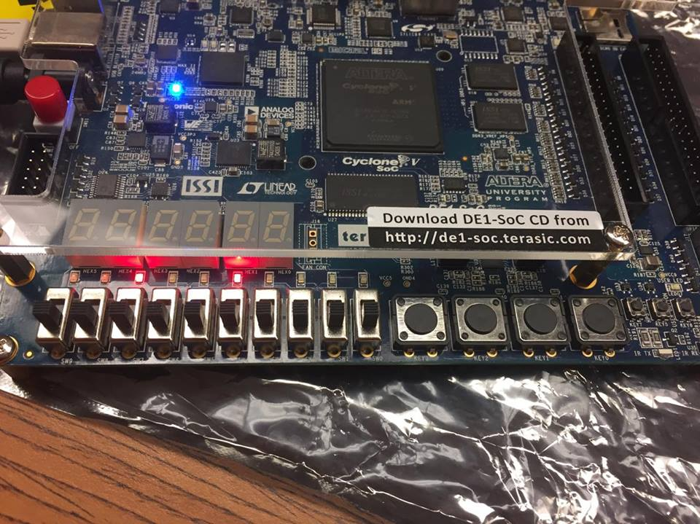Figure 27: PIN assignment on the DE1-SoC Board.

y3

y2

y1

y0

Z

V

N

c

s3

s2

s1

s0

x3

x2

x1

x0

M

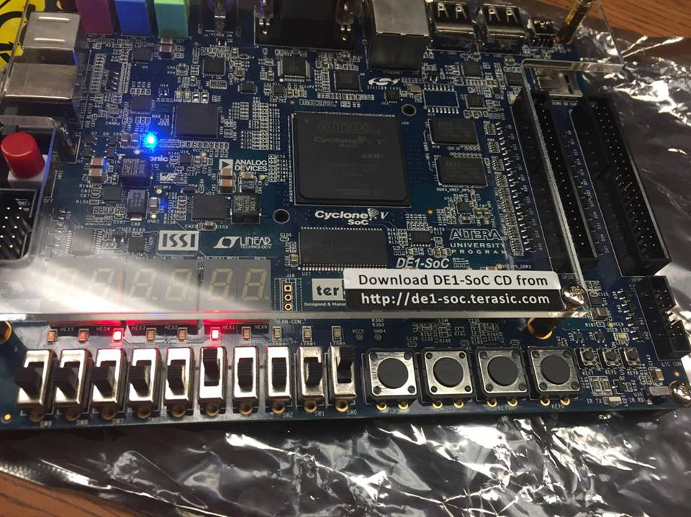Figure 28: when input x0 and y0 are 1, M is 1 it is doing subtraction therefore all s will be 0 and Z will be 1 although c is 1 but it is ignored here.

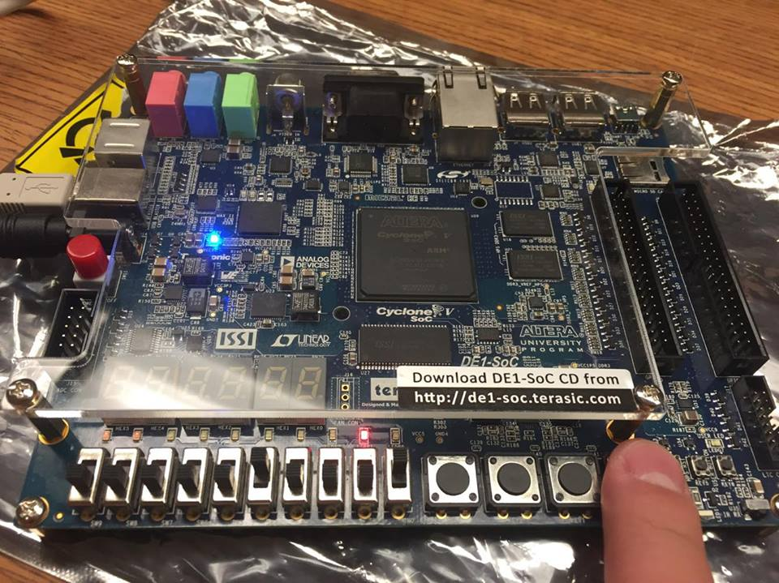Figure 29: When input x0 and y0 is 1, M is 0 it is doing addition which only s2 will be 1 and all other outputs are 0.

# **7. Conclusion**

Taking from what we have learned from the master tutorial that explained the use of basic tools for circuit design in Quartus Prime to create new project, new block diagram file, designing digital circuit, creating symbol file with designed circuit, assigning pin to inputs and outputs, running waveform simulation corresponding to designed circuit, and loading circuit to the DE1-SoC board and test designed circuit. We have successfully designed circuits for Half-Adder, One Bit Full Adder using Gates only, One Bit Full Adder using Half-Adder as component, and Four Bit Full Adder using Full Adder as component in Quartus Prime, also ran simulations corresponding to truth table that specifies the circuit designed and successfully loading the designed circuit onto the DE1-SoC board which results corresponding to the simulation for the circuit designed. It took quite some time to build subtractor on top of a 4-bit full adder, the relationships of the additional outputs that we had to insert into our circuit design was confusing since we weren’t sure what the outputs are supposed to output but in the end with teamwork we figured out the circuit and had it successfully ran on the board and produced correct computations.